

Military Division, Department of Defense Pamphlet 600-1-1 (GADOD Pam 600-1-1)

5 Jan 2022

VISUAL GUIDE TO

THE GEORGIA MILITARY AWARDS PROGRAM

FOR MANUFACTURE AND WEAR

SUMMARY of CHANGE

This new pamphlet, dated 5 Jan 2022–

* Supersedes Georgia National Guard Regulation 672-1-1 and combines elements of Georgia State Defense Force Regulation 672-1 into a single Georgia Department of Defense pamphlet, changes the number and title, and moves the proponent to the J1.
* Illustrates and describes for manufacture three new medals, five new ribbons, and six new certificates.
* Adds images of all certificates that are issued with each decoration and service medal.

TABLE OF CONTENTS

CHAPTER 1 – GENERAL

|  |  |  |
| --- | --- | --- |
| 1-1. | Page 1 | Purpose and Applicability |
| 1-2. | Page 1 | Key Abbreviations, Terms, and Definitions |
| 1-3. | Page 1 | Notes on Manufacture |

CHAPTER 2 – INDIVIDUAL DECORATIONS

|  |  |  |
| --- | --- | --- |
| 2-1. | Page 4 | Georgia Distinctive Service Medal |
| 2-2. | Page 6 | Oglethorpe Distinguished Service Medal |
| 2-3. | Page 8 | Georgia Legion of Merit |
| 2-4. | Page 10 | Georgia Medal for Heroism |
| 2-5. | Page 12 | Georgia Meritorious Service Medal |
| 2-6. | Page 14 | Georgia Commendation Medal |
| 2-7. | Page 16 | Georgia Achievement Medal |

CHAPTER 3 – CERTIFICATE OF APPRECIATION

3-1. Page 19 Georgia Department of Defense Certificate of Appreciation

CHAPTER 4 – SERVICE MEDALS

|  |  |  |
| --- | --- | --- |
| 4-1. | Page 22 | Georgia Department of Defense Service Medal |
| 4-2. | Page 24 | Georgia State Defense Force Good Conduct Medal |

CHAPTER 5 – SERVICE RIBBONS

|  |  |  |
| --- | --- | --- |
| 5-1. | Page 28 | Georgia Special Operations Ribbon |
| 5-2. | Page 28 | Georgia Pandemic Response Ribbon |
| 5-3. | Page 28 | Georgia Humanitarian Service Ribbon |
| 5-4. | Page 28 | Georgia State Active Duty Ribbon |
| 5-5. | Page 28 | Georgia Counter-Narcotics / Drug Support Service Ribbon |
| 5-6. | Page 28 | Georgia National Guard Recruiting Ribbon |

|  |  |  |
| --- | --- | --- |
| 5-7. | Page 28 | Georgia State Partnership Program Ribbon – Georgia |
| 5-8. | Page 28 | Georgia State Partnership Program Ribbon – Argentina |
| 5-9. | Page 28 | Georgia State Defense Force Volunteer Service Ribbon |
| 5-10. | Page 28 | Georgia State Defense Force Recruiting Achievement Ribbon |
| 5-11. | Page 28 | Georgia State Defense Force Soldier/NCO Enlisted Member of the Year Ribbon |
| 5-12. | Page 28 | Georgia State Defense Force Military Proficiency Ribbon |
| 5-13. | Page 28 | Georgia State Defense Force Military Qualification Training Ribbon |
| 5-14. | Page 28 | Georgia State Defense Force Emergency Service School Ribbon |
| 5-15. | Page 28 | Georgia State Defense Force Military Indoctrination Ribbon |

CHAPTER 6 – BADGES AND TABS

|  |  |  |
| --- | --- | --- |
| 6-1. | Page 30 | Georgia State Defense Force Mission Badge |
| 6-2. | Page 31 | Georgia State Defense Force Instructor Badge |
| 6-3. | Page 32 | Governor’s Twenty Tab |
| 6-4. | Page 32 | 116th Army Band Tab |
| 6-5. | Page 33 | Georgia State Defense Force Search and Rescue Specialist (SARSPEC) Tab |
| 6-6. | Page 33 | Georgia State Defense Force Opposition Force (OPFOR) Tab |
| 6-7. | Page 33 | Georgia State Defense Force Community Emergency Response Team (CERT) Tab |

CHAPTER 7 – UNIT DECORATIONS

7-1. Page 35 Georgia Distinguished Unit Ribbon

APPENDIX A Page 37 Additional Illustrations APPENDIX B Page 39 Glossary of Awards and Heraldry

This pamphlet supersedes and combines Georgia National Guard and Georgia State Defense Force regulations into a single Georgia Department of Defense pamphlet. This visual guide is the companion to Georgia Department of Defense Regulation (GADODR) 600-1, dated 5 Jan 2022.

The proponent agency of this publication is the J1, Joint Force Headquarters – Georgia.



THOMAS M. CARDEN, JR.

Major General, GA NG The Adjutant General

This page left intentionally blank

# CHAPTER 1 – GENERAL

## 1-1. PURPOSE AND APPLICABILITY

1. This pamphlet is a companion to the military awards program for the Georgia Department of Defense and outlines descriptions of the physical materials of the awards program.
2. Per Georgia Code, Title 38, *Military, Emergency Management, and Veterans Affairs*, §§ 38-2-20 thru 38-2-23, the "organized militia," which constitutes the military division of the Georgia Department of Defense (GA DOD), includes the Georgia Army National Guard (GAARNG), the Georgia Air National Guard (GAANG), and the Georgia State Defense Force (GASDF).

## 1-2. KEY ABBREVIATIONS, TERMS, AND DEFINITIONS

1. See Georgia Department of Defense Regulation (GADODR) 600-1 for definitions related to an awards program, including the terms "decoration," "medal," and "award."
2. See appendix B of this pamphlet for terms specific to heraldry and manufacture.

## 1-3. NOTES ON MANUFACTURE.

1. Medals. Except as noted, all medals are cast in bronze and are suspended from a *moiré* silk ribbon, 1 3/8 inches in length and 1 3/8 inches in width.
2. Ribbons. Manufacturers will use the standard US military ribbon size, 3/8 inches in height and 1 3/8-inches in length. Ribbon bars will be identical in color to the suspension ribbon of the medals they represent, and of such construction that the ribbon may be detached and mounted on longer bars with other ribbons. Ribbons will not be permeated with unnatural preservatives, nor worn with protective coverings.
3. Certificates.
   1. Will be printed on bond paper, of a vellum or similar natural (non-white) color.
   2. Will provide a place at the bottom for the signature of the approval authority. It will not contain a pre-printed signature block, except for the words “The Adjutant General” on those awards specifically approved by The Adjutant General.
   3. Will print illustrated seals and decorations in gold foil.
   4. Will print illustrated ribbons embossed, flying from the center, and terminating like that of a *forked pennon*.
4. Appurtenances.
   1. Boar’s Head device. See appendix A.
   2. Oak Leaf Cluster. The standard US military device in the shape of a twig of four oak leaves with three acorns on the stem, which is bronze, silver, or gold in color, 5/16 inches in length. May be manufactured in horizontally aligned groups of 2, 3, or 4.
   3. Numerals. The standard US military device in the shape of Arabic numbers, which is bronze in color, 3/16 inches in height.
   4. “H” device. Like the standard US military device for other letters (such as the “V” device), which is bronze in color, 1/4 inch in height.
   5. Clasps. The standard US military device in the shape of a bar with loops (“knots”), which is bronze, silver, or gold in color, 1 3/8 inches in length.
   6. Service Stars. The standard US military device in the shape of a five-pointed star, which is bronze, silver, or gold in color, 3/16 inches in diameter.

# CHAPTER 2 – INDIVIDUAL DECORATIONS

## BY ORDER OF PRECEDENCE

Georgia Distinctive Service Medal Oglethorpe Distinguished Service Medal Georgia Legion of Merit

Georgia Medal for Heroism Georgia Meritorious Service Medal Georgia Commendation Medal Georgia Achievement Medal

## GEORGIA DISTINCTIVE SERVICE MEDAL

Obverse: Cast in bronze metal. A disc, 1 1/2 inches in diameter. Centered is the seal of the state of Georgia, *stiacciato*, 1/2 inches in diameter. Surrounded by a laurel wreath in a recessed *annulet*, 3/4 inches in diameter and containing 34 leaves and tied at the bottom with a ribbon. Further surrounded by the words "GEORGIA NATIONAL GUARD" (above) and "FOR MERITORIOUS SERVICE" (below). The medal contains a circular ring at the top to receive the suspension ribbon.

Reverse: Six lines, from top to bottom: "AWARDED" / "TO" / (a large empty scroll to engrave name of recipient) / "FOR" / "MERITORIOUS SERVICE" / (a small empty tablet to engrave medal number, superimposed over a sprig of laurel on either side).

The ribbon is composed of vertical stripes of ultramarine blue (5/32 inch), white (3/16 inch), red (5/32 inch), Confederate Gray [[center 3/8 inch]]. Mirrored on the opposite side.

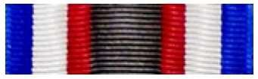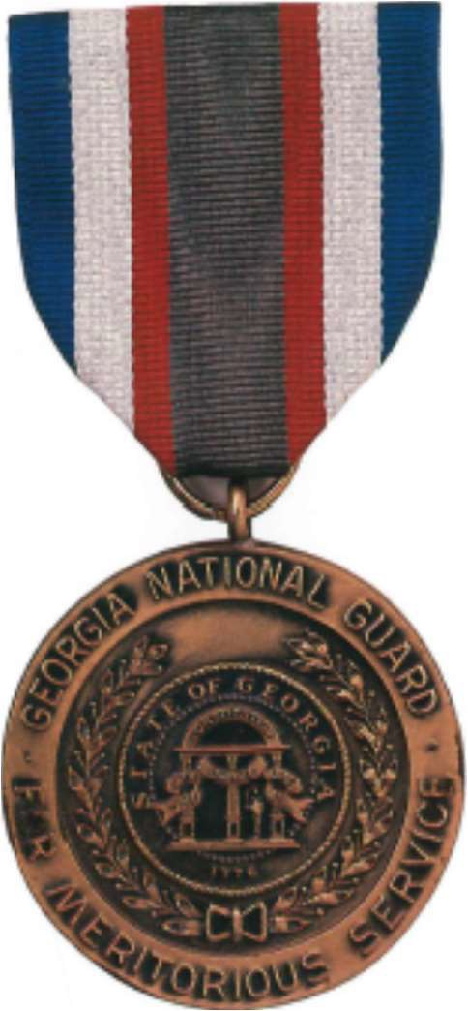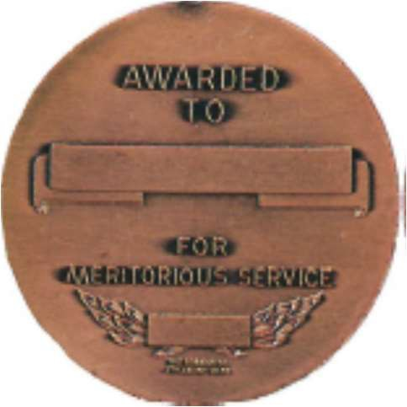

Obverse Reverse

## GEORGIA DISTINCTIVE SERVICE MEDAL (CERTIFICATE)

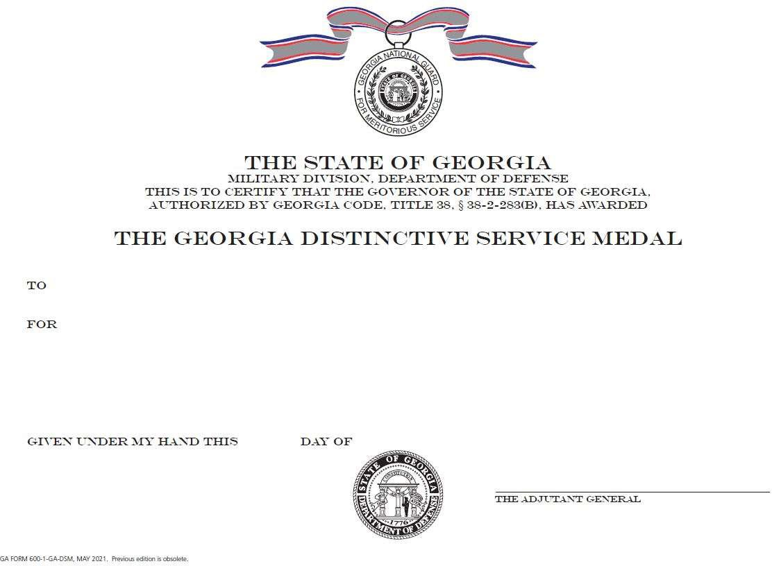

**OGLETHORPE DISTINGUISHED SERVICE MEDAL**

Obverse: Cast in bronze metal, polished and enameled. On a sunburst, 1 22/32 inches in diameter, containing eight individual bronze rays, is an eight-armed Maltese cross, 2 3/8 inches in diameter. The arms are bronze, bordered thin, with white enamel inlaid and with bars down the center of the arms, those with purple enamel inlaid, extended unevenly. Superimposed on the center of the cross is a disc, 9/32 inches in diameter, bronze and with a large, three-color image of the military crest of Georgia enameled and inlaid. The medal contains a circular ring at the top to receive the suspension ribbon.

Reverse: Five lines, from top to bottom: "FOR" / "DISTINGUISHED" / "SERVICE" / (a large empty tablet to engrave name of recipient) / "GEORGIA".

The medal is suspended from a deep blue (ultramarine) *moiré* silk ribbon neck drape. The drape contains a metal snap at the back.

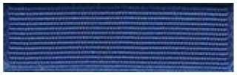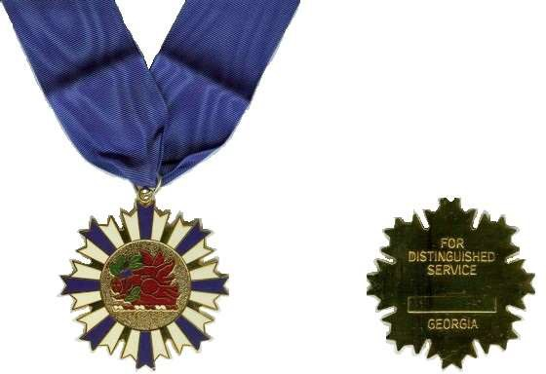

Obverse Reverse

## OGLETHORPE DISTINGUISHED SERVICE MEDAL (CERTIFICATE)

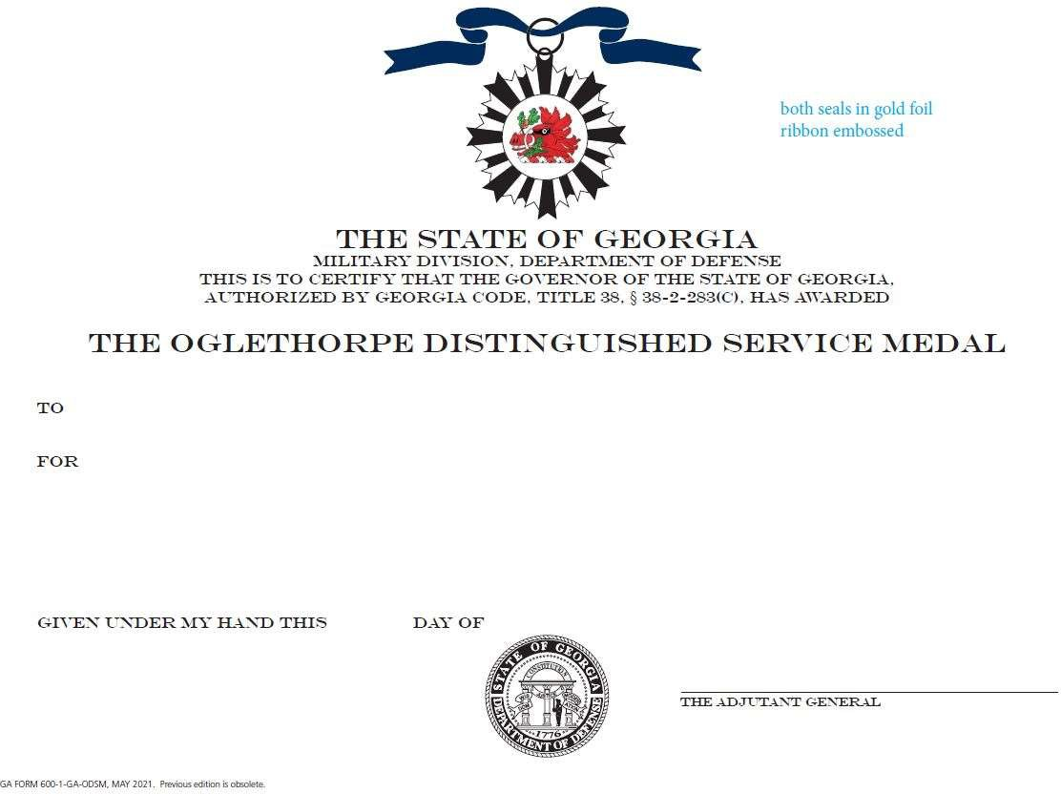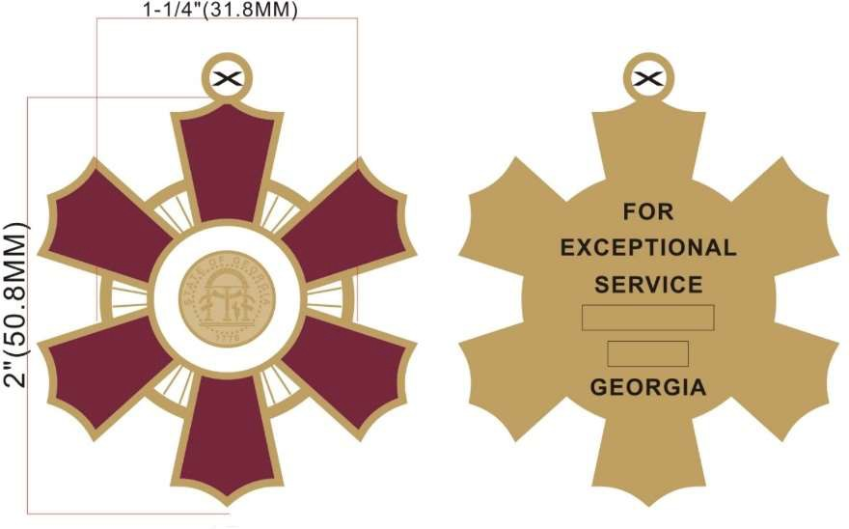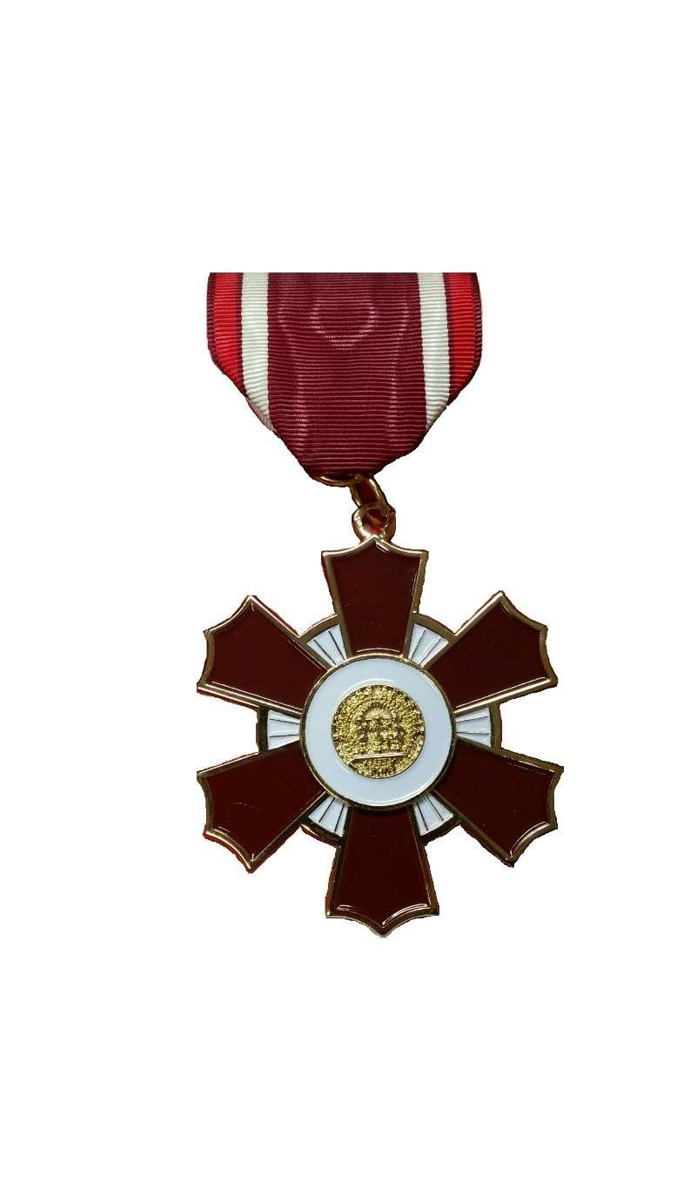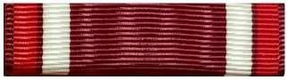

**GEORGIA LEGION OF MERIT**

Obverse: Cast in bronze metal, polished and enameled. On a sunburst containing eighteen visible rays, 1 1/4 inches in diameter, is a six-pointed cross *clechée*, 2 inches in diameter. The arms are bronze, *exscinded* and bordered thin, with dark red-brown enamel inlaid. The rays have white enamel inlaid. Superimposed on the center of the cross is the seal of the state of Georgia, 1/2 inch in diameter, in bronze, *stiacciato*. The seal is surrounded by a disc, 3/4 inches in diameter, bronze and with white polished enamel inlaid. The medal contains a circular ring at the top to receive the suspension ribbon.

Reverse: Six lines, from top to bottom: "FOR" / "EXCEPTIONAL" / "SERVICE" / (a large empty tablet to engrave name of recipient) / (a small empty tablet to engrave medal number) / "GEORGIA".

The ribbon is composed of vertical stripes of dark red-brown (1/32 inch), red (1/8 inch), dark red-brown (1/32 inch), white (1/8 inch), dark red-brown [[center 6/8 inch]]. Mirrored on the opposite side.

Obverse Reverse

## GEORGIA LEGION OF MERIT (CERTIFICATE)

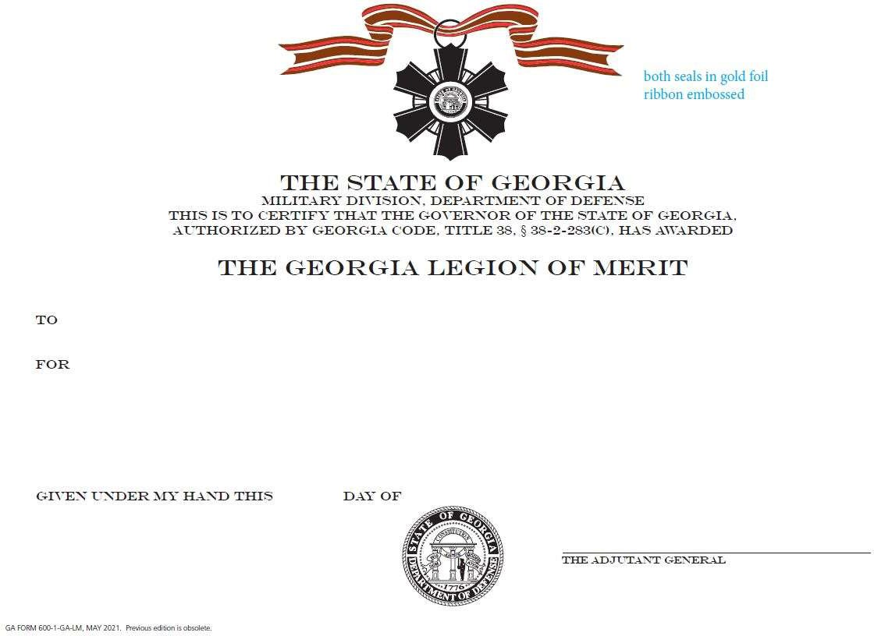

**GEORGIA MEDAL FOR HEROISM**

Obverse: Cast in bronze metal, polished and enameled. On a sunburst containing 16 visible rays, 1 inch in diameter, is an irregular, four-armed cross *clechée*, 1 1/2 inches high, 1 13/32 inches wide, with three equal arms and one longer arm at the top. The arms are bronze, *exscinded* and bordered thin, with dark red enamel inlaid. Superimposed on the center of the cross is a bronze seal of the state of Georgia, 7/16 inches in diameter, *stiacciato*. The medal contains an oblong horizontal ring at the top to receive the suspension ribbon.

Reverse: Beveled edges. Four lines, from top to bottom: "FOR" / "HEROISM" / (a large empty tablet to engrave name of recipient) / "GEORGIA". Older medals had “VALOR,” but this is changed as of the date of this publication.

The ribbon is composed of vertical stripes of Confederate Gray (1/8 inch), white (1/8 inch), red [[center 7/8 inch]]. Mirrored on the opposite side.

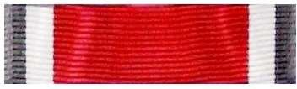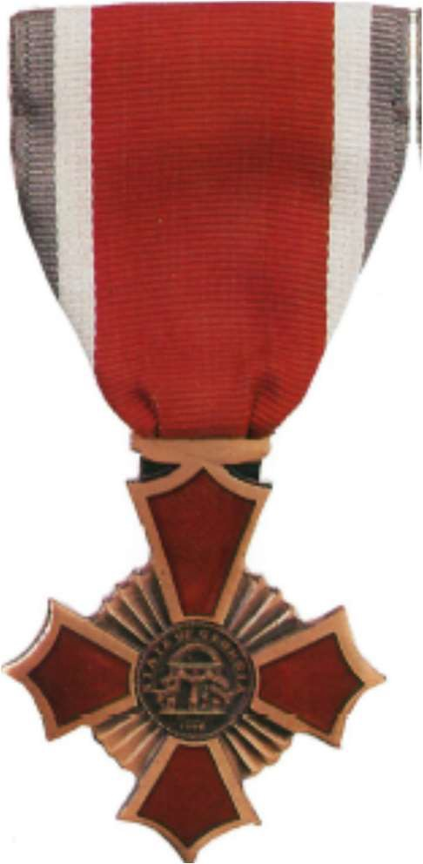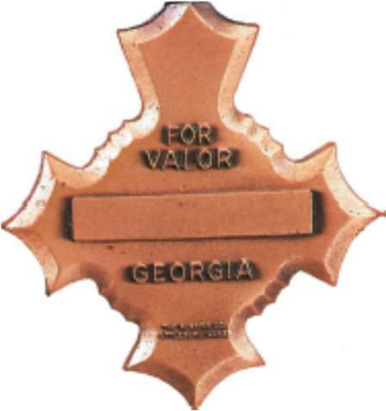

Obverse Reverse

## GEORGIA MEDAL FOR HEROISM (CERTIFICATE)

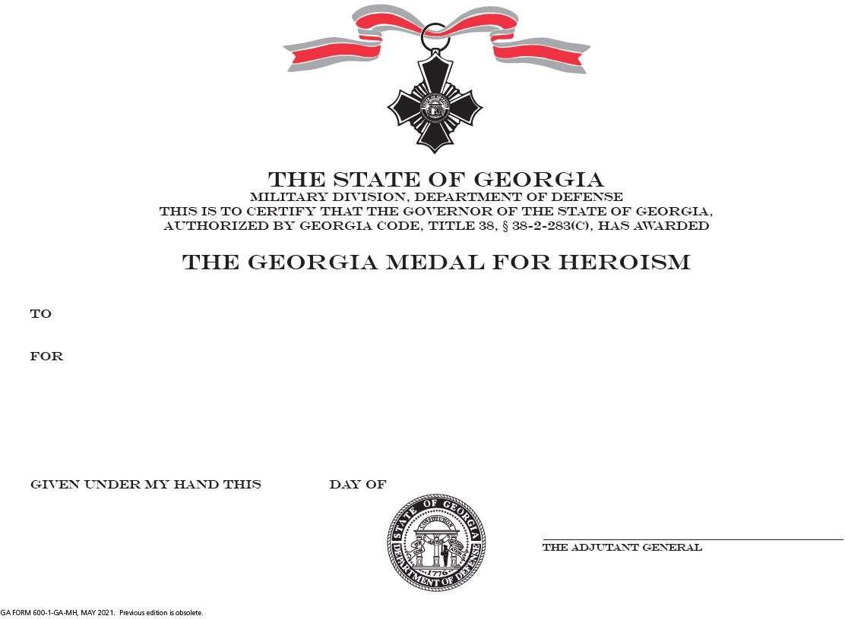

**GEORGIA MERITORIOUS SERVICE MEDAL**

Obverse: Cast in bronze metal, polished and enameled. On a sunburst containing 16 visible rays, 1 inch in diameter, is a four-armed cross *clechée*, 1 1/4 inches in diameter. The arms are bronze, *exscinded* and bordered wide, with dark red enamel inlaid. Superimposed on the center of the cross is a bronze seal of the state of Georgia, 3/4 inches in diameter, *stiacciato*. Surrounding the cross and detached from the rays is a laurel wreath, 1 3/4 inches in diameter, bronze and with green enamel inlaid, on two branches, with stems crossing at the bottom and with the top leaves touching the outer points of the top segment of the cross. The medal contains an oblong horizontal ring at the top to receive the suspension ribbon.

Reverse: Six lines, from top to bottom: "FOR" / "MERITORIOUS" / "SERVICE" / (a large empty tablet to engrave name of recipient) / (an empty space to engrave medal number) / "GEORGIA".

The ribbon is composed of vertical stripes of Confederate Gray (1/8 inch), white (1/8 inch), ultramarine blue [[center 7/8 inch]]. Mirrored on the opposite side.

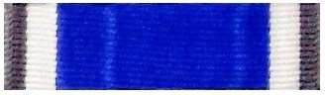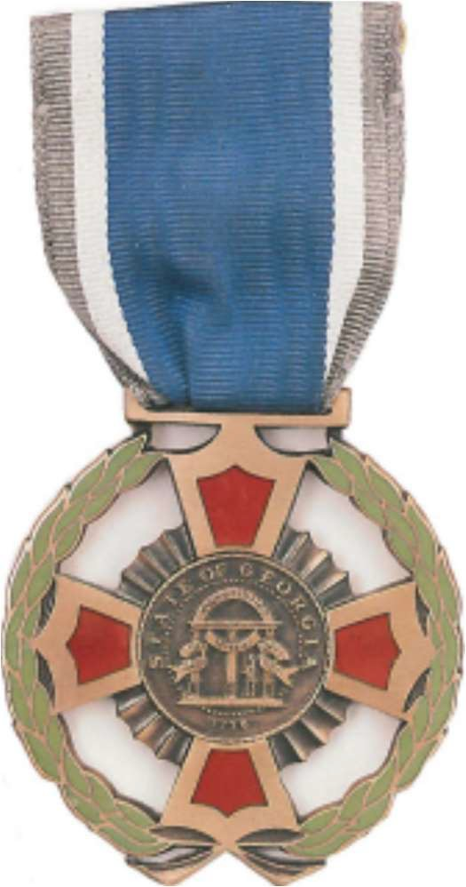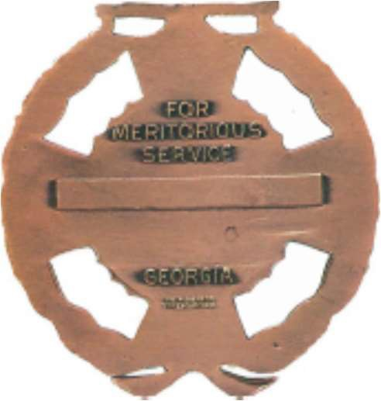

Obverse Reverse

## GEORGIA MERITORIOUS SERVICE MEDAL (CERTIFICATE)

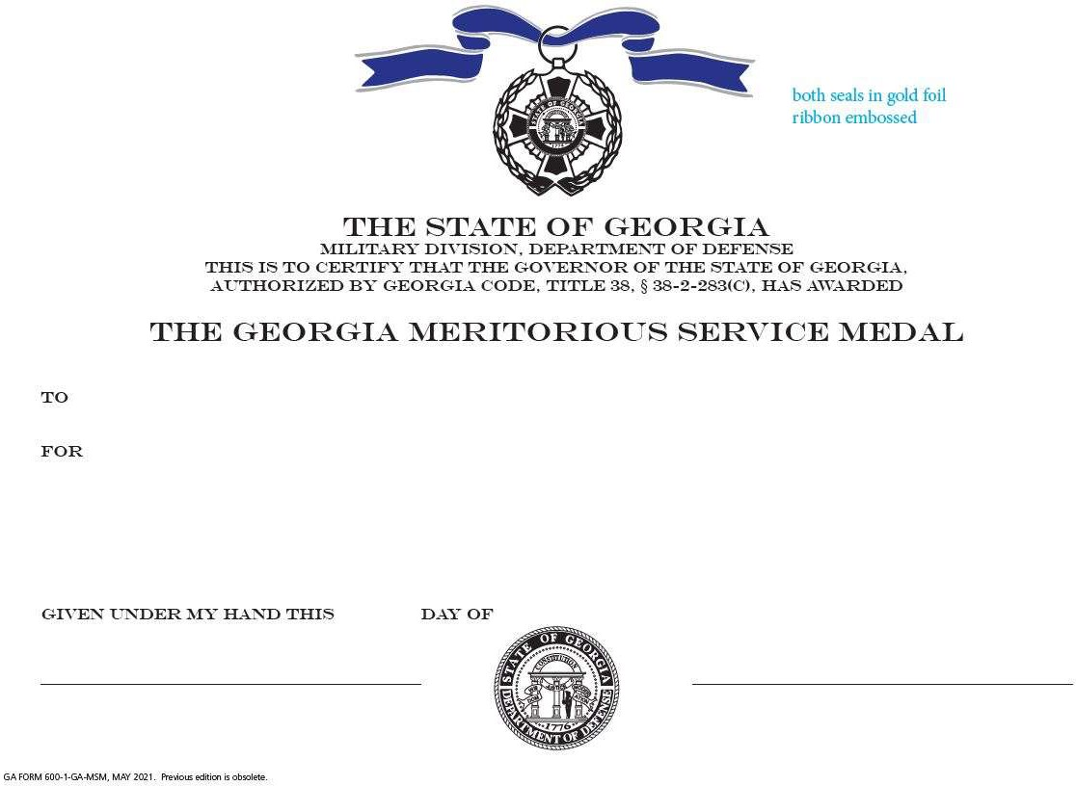

**GEORGIA COMMENDATION MEDAL**

Obverse: Cast in bronze metal. On a disk measuring 1 9/16 inches is a cross *patonce*, having three rays in each arm, extended unevenly. The cross is 1 3/4 inches in diameter, with stylized laurels between the angles. The disc bears the Latin inscription "NON" and "SIBI" (above), "SED" and "ALIIS" (below) ("Not for ourselves, but for others.") Superimposed in the center, the seal of the state of Georgia, 1/2 inches in diameter, *stiacciato*, surrounded by a recessed *annulet*, 7/8 inches in diameter, with the words "GEORGIA" (above) and "COMMENDATION" (below). The medal contains a circular ring at the top to receive the suspension ribbon.

Reverse: Six lines, from top to bottom: "OUSTANDING" / "SERVICE" / "RENDERED" / "NATIONAL GUARD" / (a large empty tablet to engrave name of recipient) / (a small empty tablet to engrave medal number).

The ribbon is composed of vertical stripes of red (1/4 inch), white (1/8 inch), ultramarine blue (1/4 inch), white [[center 1/8 inch]]. Mirrored on the opposite side.

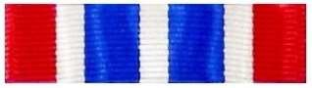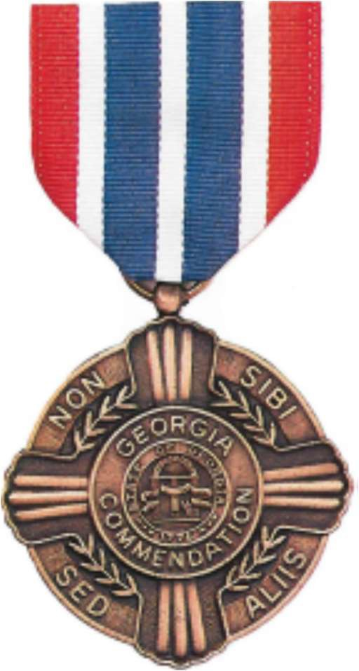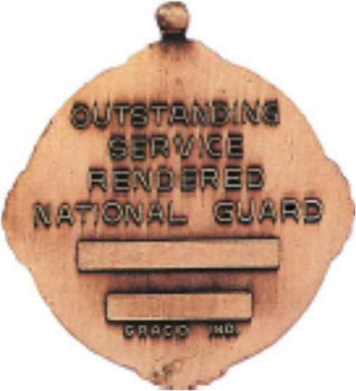

Obverse Reverse

## GEORGIA COMMENDATION MEDAL (CERTIFICATE)

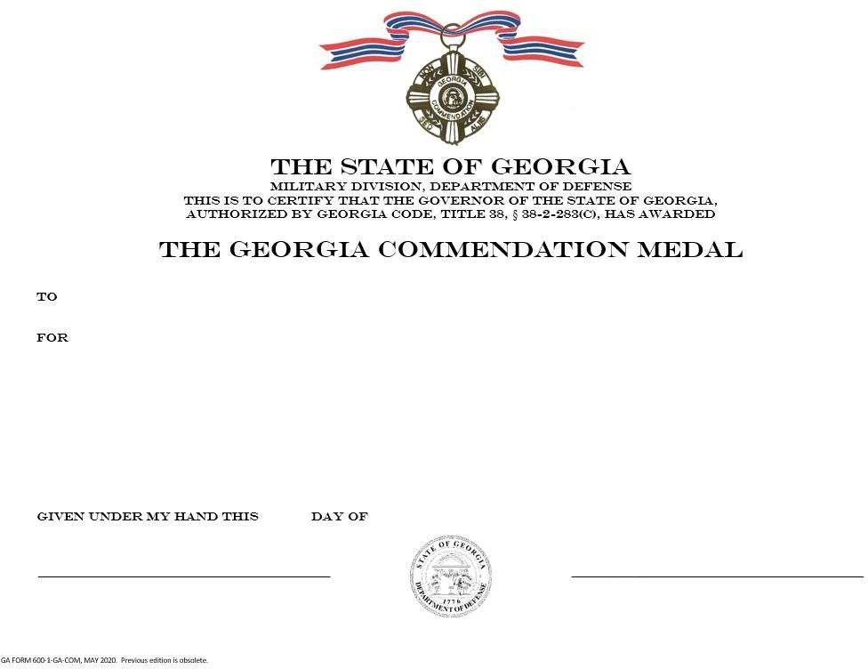

**GEORGIA ACHIEVEMENT MEDAL**

Obverse: Cast in bronze metal. A hexagon, 1 1/2 inches in diameter, standing on one point.

Superimposed in the center is the military crest of the state of Georgia, 5/8 inches in diameter, *stiacciato*. The crest is framed in a disc, 7/8 inches in diameter, containing the words “STATE OF GEORGIA” (above) and “FOR ACHIEVEMENT” (below). A cog with eight teeth, 1 1/4 inches in diameter, surrounds the disc. The medal contains a circular ring at the top to receive the suspension ribbon.

Reverse: Empty.

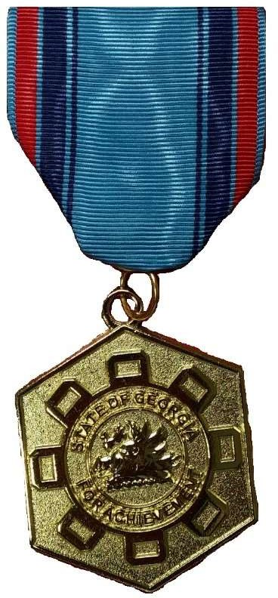The ribbon is composed of vertical stripes of pale blue (1/32 inch), red (1/8 inch), pale blue (1/32 inch), dark blue (1/8 inch), pale blue (1/32 inch), dark blue (1/32 inch), pale blue [[center 5/8 inch]]. Mirrored on the opposite side.

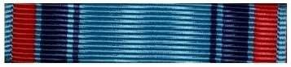

(Empty)

Obverse Reverse

## GEORGIA ACHIEVEMENT MEDAL (CERTIFICATE)

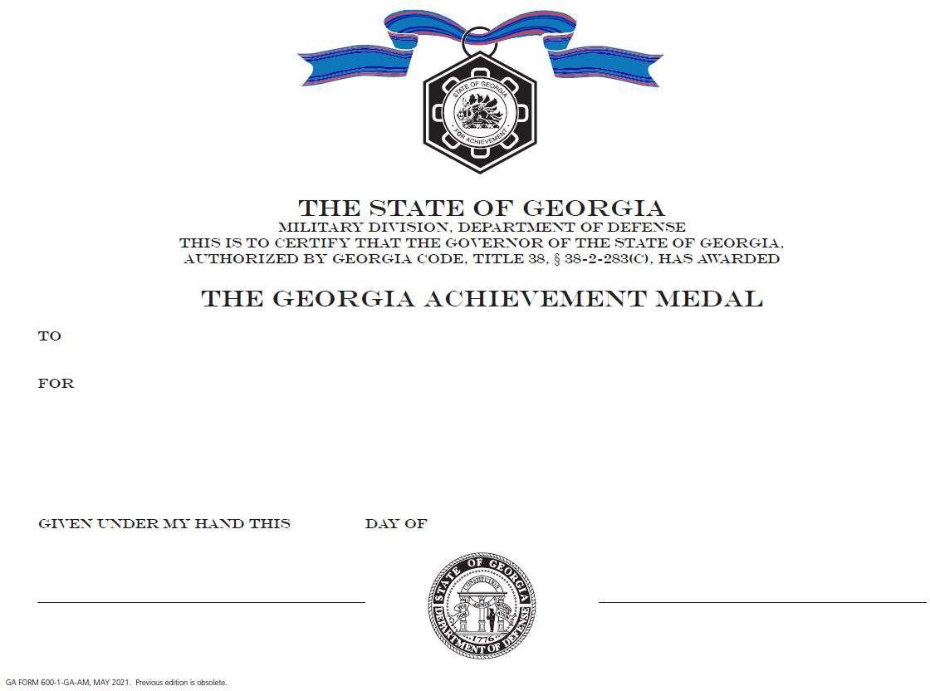

This page left intentionally blank

# CHAPTER 3 – CERTIFICATE OF APPRECIATION

## GEORGIA DEPARTMENT OF DEFENSE CERTIFICATE OF APPRECIATION

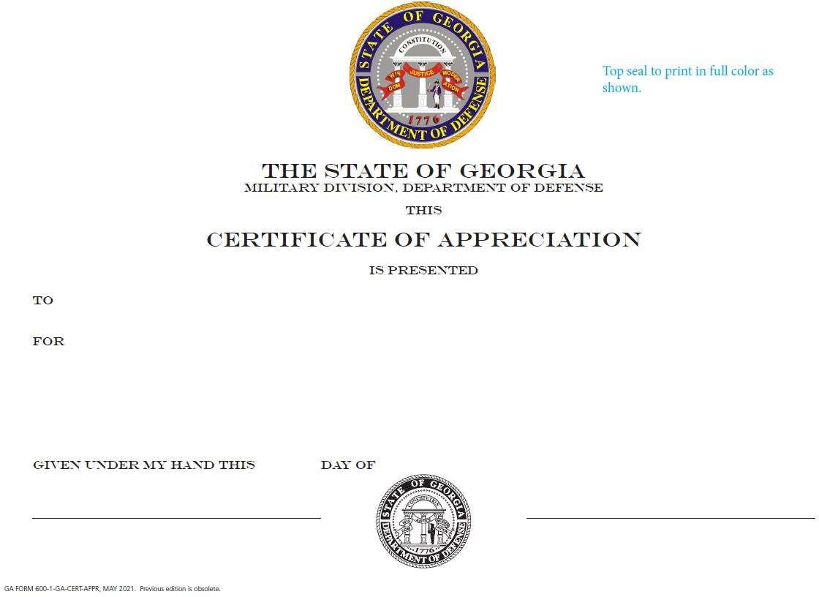

This page left intentionally blank

# CHAPTER 4 – SERVICE MEDALS

## BY ORDER OF PRECEDENCE

Georgia Department of Defense Service Medal Georgia State Defense Force Good Conduct Medal

## GEORGIA DEPARTMENT OF DEFENSE SERVICE MEDAL

Obverse: Cast in bronze, a map outline of the state of Georgia, 1 3/4 inches high and 1 3/8 inches at the widest point. In the base center is a circle containing the seal of the state of Georgia, 1 inch in diameter, *stiacciato*. Alighting on the seal from the left, at 11:30 o'clock, is a bald eagle, *stiacciato*, with head bowed toward the wearer's left, and wings outstretched pointing to the northeast and northwest corners of the Georgia state map outline. Across the bottom of the map is the word "SERVICE." The top of the medal contains a ring from which the medal is suspended.

Reverse: In the center, the military crest of Georgia, 5/8 inches high and 3/4 inches wide. Three lines above, from top to bottom: "FOR" / "HONEST AND FAITHFUL" / "SERVICE". Three lines below, from top to bottom: (a large empty tablet to engrave name of recipient) / "GEORGIA" / "NATIONAL GUARD".

The ribbon is composed of vertical stripes of red (1/4 inch), white (1/8 inch), Confederate Gray [[center 5/8 inch]]. Mirrored on the opposite side, except the final stripe is blue, not red.

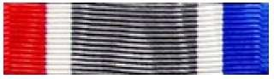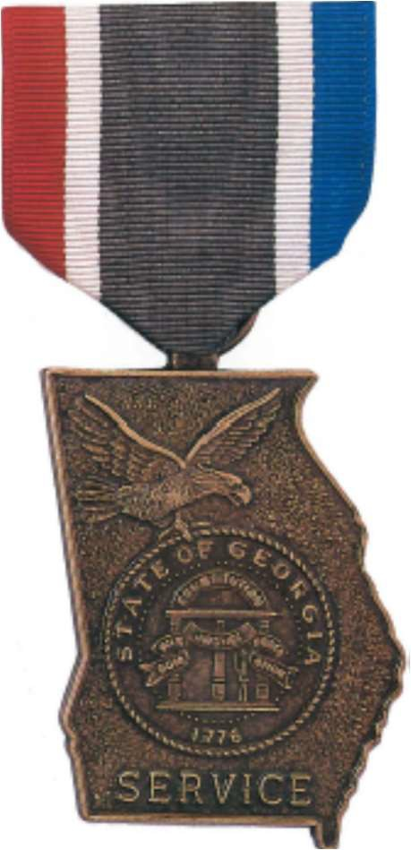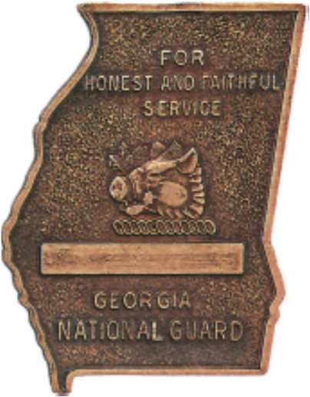

Obverse Reverse

## GEORGIA DEPARTMENT OF DEFENSE SERVICE MEDAL (CERTIFICATE)

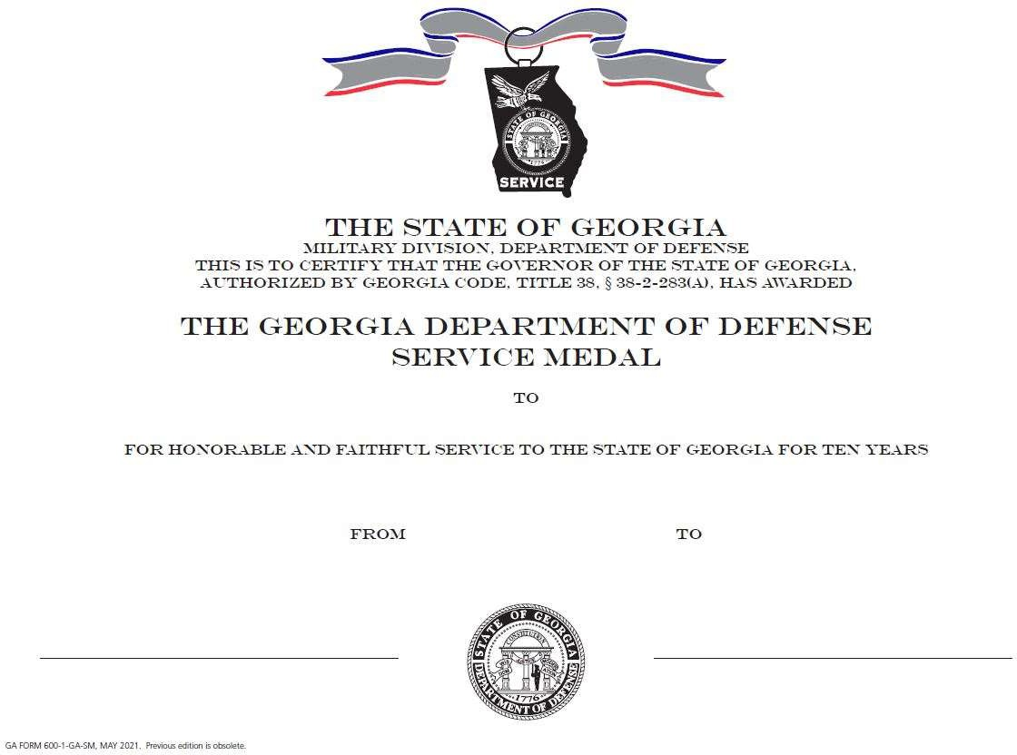

**GEORGIA STATE DEFENSE FORCE GOOD CONDUCT MEDAL**

Obverse: Cast in bronze metal. A disc, 1 1/2 inches in diameter. In the center, the pillars and arch from the state seal of Georgia, 1/2 inches in diameter, *stiacciato*, framed by a laurel wreath *torc* (above) and with the words “HONEST AND FAITHFUL” (below). The medal contains a circular ring at the top to receive the suspension ribbon. The elements of this medal are based on the original Active Service Badge from 1916 and the Active Service Medal from 1931.

Reverse: Empty.

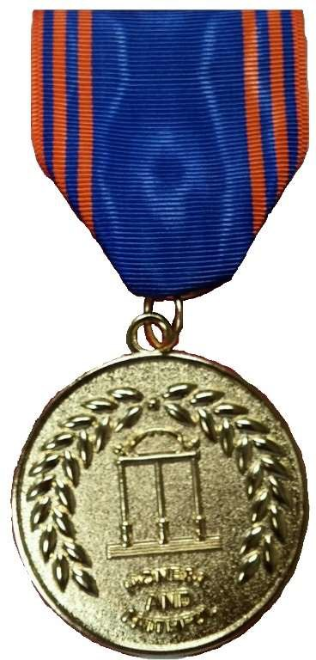The ribbon is composed of vertical stripes of orange (1/16 inch), blue (1/16 inch), orange (1/16 inch), blue (1/16 inch), orange (1/16 inch), blue [[center 3/4 inch]]. Mirrored on the opposite side.

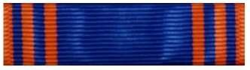

(Empty)

Obverse Reverse

## GEORGIA STATE DEFENSE FORCE GOOD CONDUCT MEDAL (CERTIFICATE)

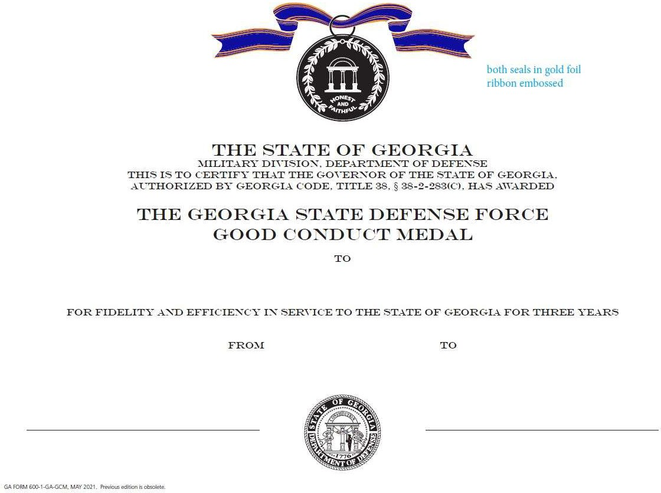

This page left intentionally blank

# CHAPTER 5 – SERVICE RIBBONS

## BY ORDER OF PRECEDENCE

Georgia Special Operations Ribbon Georgia Pandemic Response Ribbon Georgia Humanitarian Service Ribbon Georgia State Active Duty Ribbon

Georgia Counter-Narcotics / Drug Support Service Ribbon Georgia National Guard Recruiting Ribbon

Georgia State Partnership Program Ribbon – Georgia Georgia State Partnership Program Ribbon – Argentina Georgia State Defense Force Volunteer Service Ribbon Georgia State Defense Force Recruiting Achievement Ribbon

Georgia State Defense Force Soldier/NCO Enlisted Member of the Year Ribbon Georgia State Defense Force Military Proficiency Ribbon

Georgia State Defense Force Military Qualification Training Ribbon Georgia State Defense Force Emergency Service School Ribbon Georgia State Defense Force Military Indoctrination Ribbon

## SERVICE RIBBONS

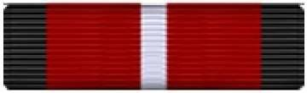 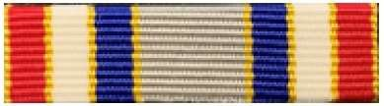 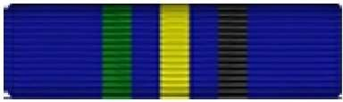

Georgia Special Operations

Ribbon

Georgia Pandemic Response

Ribbon

Georgia Humanitarian Service Ribbon

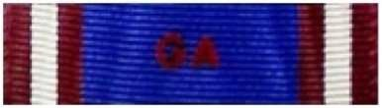 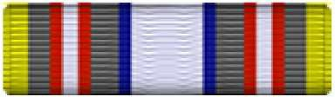 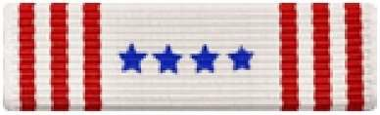

Georgia State Active Duty

Ribbon

Georgia Counter-Narcotics / Drug Support Service Ribbon

Georgia National Guard Recruiting Ribbon

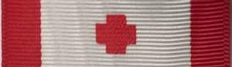 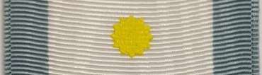 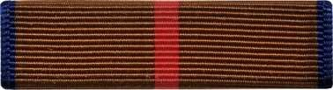

Georgia State Partnership Program Ribbon – Georgia

Georgia State Partnership

Program Ribbon – Argentina

GASDF Volunteer Service Ribbon

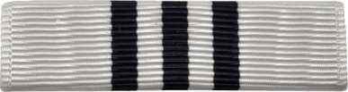 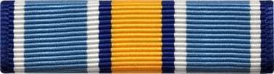 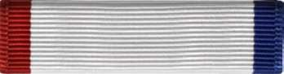

GASDF Recruiting Achievement

Ribbon

GASDF Soldier/NCO Enlisted Member of the Year Ribbon

GASDF Military Proficiency

Ribbon

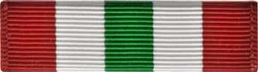 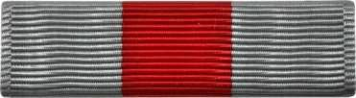 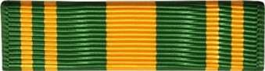

GASDF Military Qualification Training Ribbon

GASDF Emergency Service School Ribbon

GASDF Military Indoctrination

Ribbon

# CHAPTER 6 – BADGES AND TABS

## BADGES

Georgia State Defense Force Mission Badge Georgia State Defense Force Instructor Badge

## TABS

Governor’s Twenty Tab 116th Army Band Tab

Georgia State Defense Force Search and Rescue Specialist (SARSPEC) Tab Georgia State Defense Force Opposition Force (OPFOR) Tab

Georgia State Defense Force Community Emergency Response Team (CERT) Tab

## GEORGIA STATE DEFENSE FORCE MISSION BADGE

A disc containing the seal of the Georgia Department of Defense. To either side of the disc, ribbons and laurels extending horizontally. Above the disc, Basic: nothing, Senior: a five-pointed star, Master: a wreath encircling a five-pointed star.

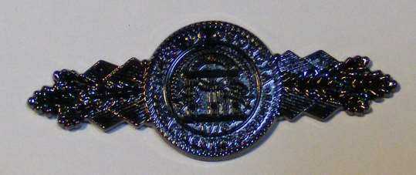

**BASIC MISSION BADGE**

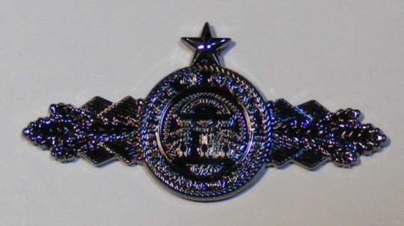

**SENIOR MISSION BADGE**

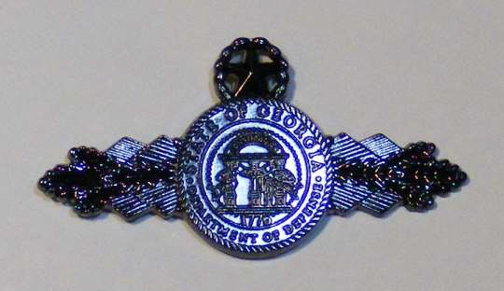

**MASTER MISSION BADGE**

**GEORGIA STATE DEFENSE FORCE INSTRUCTOR BADGE**

A disc, 2 1/2 inches in diameter, green with red and silver accents, containing the three pillars and arch of the seal of the state of Georgia, with the words “PARATI” (left) and “SERVIRE” (right) (“ready to serve,” the motto of the Georgia State Defense Force), and with the words “Instructor” (above) and “TRAIN THE FORCE” (below). In the center, Basic: a lit torch, Master: a wreath of laurels encircling a lit torch.

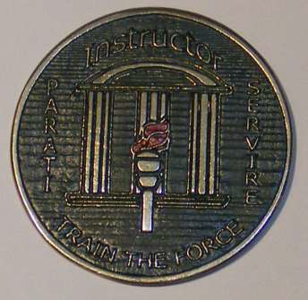

**INSTRUCTOR BASIC INSTRUCTOR MASTER**



**INSTRUCTOR BASIC SUBDUED**

**INSTRUCTOR MASTER SUBDUED**

**GOVERNOR’S TWENTY TAB**

A semicircular arc-shaped tab with the words “GOVERNORS TWENTY.”

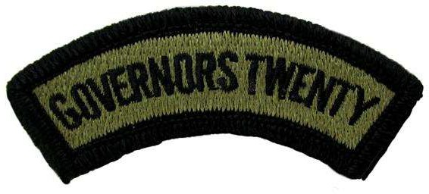

## 116TH ARMY BAND TAB

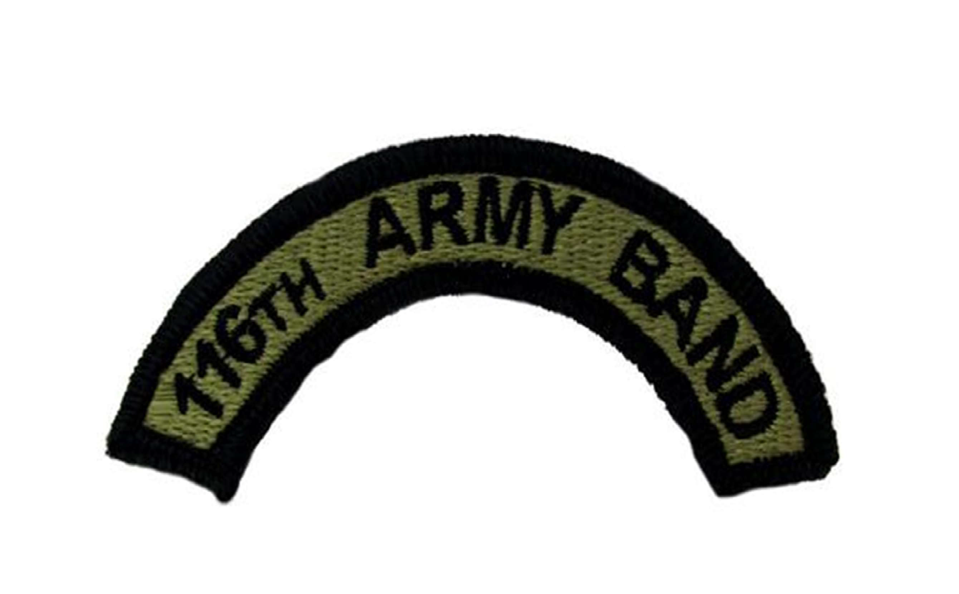A semicircular arc-shaped tab with the words “116TH ARMY BAND."

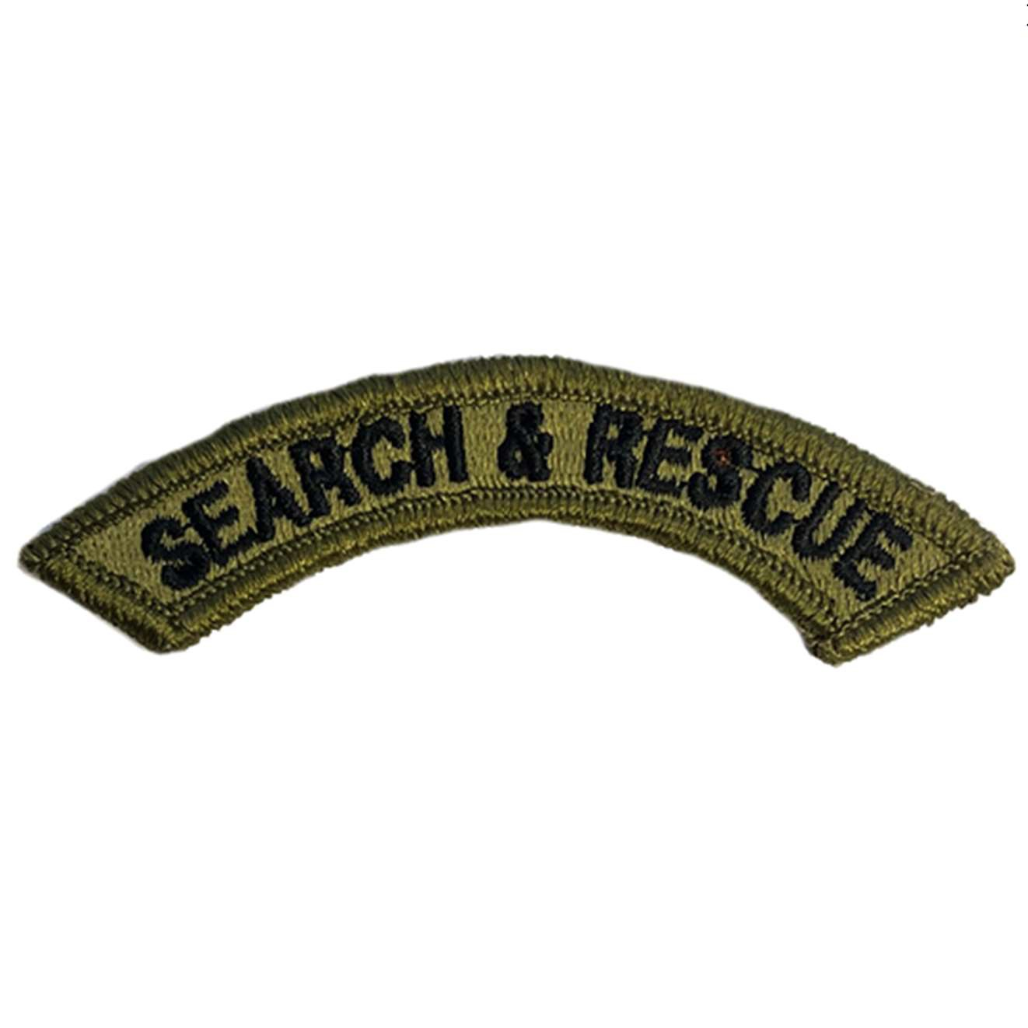DOD Pam 600-1-1

GA

## GEORGIA STATE DEFENSE FORCE SEARCH AND RESCUE SPECIALIST (SARSPEC) TAB

A semicircular arc-shaped tab with the words “SEARCH & RESCUE” in capital letters.

## GEORGIA STATE DEFENSE FORCE OPPOSITION FORCE (OPFOR) TAB

A rectangular tab with the acronym “OPFOR” in capital letters.

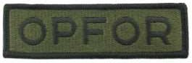

## GEORGIA STATE DEFENSE FORCE COMMUNITY EMERGENCY RESPONSE TEAM (CERT) TAB

A semicircular arc-shaped tab with the acronym “CERT” in capital letters.

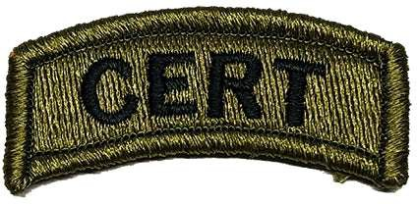

This page left intentionally blank

# CHAPTER 7 – UNIT DECORATIONS

## GEORGIA DISTINGUISHED UNIT RIBBON

The ribbon is vertically half red, half white, in a frame gold in color with a wheat design. When worn, the red portion is on the wearer's right and the wheat is oriented in the direction in which wheat grows.

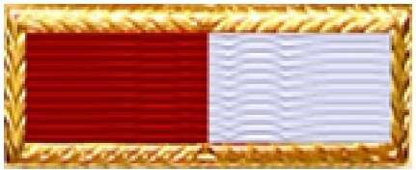

**GEORGIA DISTINGUISHED UNIT RIBBON (LARGE CERTIFICATE SUITABLE FOR FRAMING)**

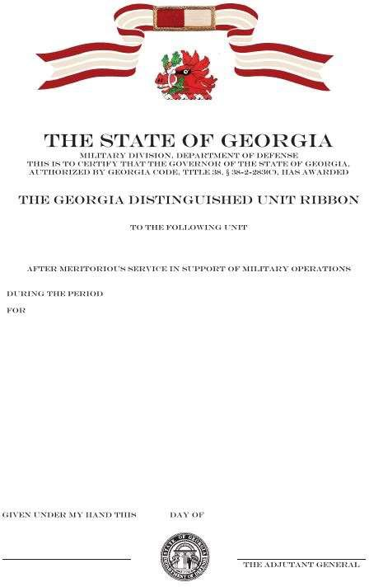

# APPENDIX A – ADDITIONAL ILLUSTRATIONS

## SEAL OF THE STATE OF GEORGIA

The seal of the state government, including its several departments.



## SEAL OF THE GEORGIA DEPARTMENT OF DEFENSE

The seal specific to the military division of the state government.



## MILITARY CREST OF GEORGIA

This crest was approved by the Institute of Heraldry 20 March 1922. The red boar’s head with green oak branch and yellow acorn is from the family crest of Sir James Oglethorpe, the founder of the colony of Georgia. The boar is the heraldic symbol of courage and ferocity in attack. A boar’s head is also the classical symbol of hospitality. Note that the wreath is left empty of colors; each unit to which this crest is assigned will incorporate their unit colors into the wreath.

Heraldry description for manufacture: *From* a flat *torse*, the *charge* a boar's head *erased close*, *Gules*, facing *dexter in trian aspect*, and in the mouth an oak branch with six leaves, *Vert*, *fructed Or*.



## BOAR’S HEAD DEVICE (APPURTENANCE)

Based on the military crest of Georgia, which is bronze or silver in color, 7/16 inches long and 1/4 inches high, on a wreath with alternating red and white colors to signify the English origins of the colony of Georgia. The boar's head faces the wearer's right, worn such that the wreath is parallel to the ground. It is fastened to both the service ribbon and the metal pendant by means of bronze staples incorporated as part of the appurtenance.

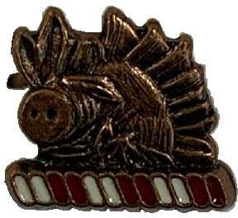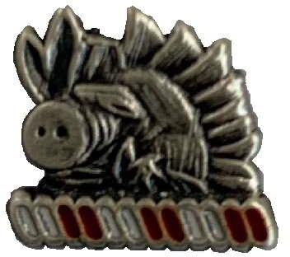

Bronze device Silver device

# APPENDIX B – GLOSSARY OF AWARDS AND HERALDRY

Definitions are based on *A Glossary Of Terms Used In Heraldry*, 1894, by James Parker; and on *A Complete Guide To Heraldry*, 1909, by Arthur Charles Fox-Davies.

Both works are in the public domain.

### affront / affronté / affronty

Displayed facing directly at the observer.

### annulet

A *charge* in the form of a small, circular ring.

### Argent

Silver *tincture*.

### Azure

Dark blue *tincture*.

### charge

Centerpiece.

### clechée

Branching straight out from the center and flaring out to three sharp or rounded points at the end, resembling the shape of a common French Medieval key handle.

### close

A reference to something (such as an animal’s head or claw) removed neatly and without any part of the neck or limb remaining attached to it.

### couped

Having a straight edge, as if cut (off) cleanly with a sword.

### dexter

Displayed facing to the right of the shield as worn; that is, to the observer’s left.

### embossed

Raised from the surface.

### enamel

A paint that dries to a hard and glossy finish.

### erased

A reference to something (such as an animal’s head or claw) violently torn off and leaving a jagged edge (such as the boar’s head).

### exscinded

Cut out or hollowed out.

### forked

Split into two tapering points.

### fructed

With fruit displayed, usually drawn out of proportion to its relative size. A branch, slip, bush, or tree is termed *fructed* when the fruit is shown (such as the acorn on the oak branch in the mouth of the boar’s head).

### Gules

Dark red *tincture*.

### inlaid

An object ornamented by embedding a different material into it, flush with its surface.

### Maltese cross

A quadrilateral symbol with extending arms of equal lengths that broaden from the center, terminating in sharp points and indented, resembling shallow “V” shapes.

### moiré

A textile with a wavy and lustrous appearance, due to the weave and press effects upon the cloth.

### obverse

Front side of an object, such as a medallion.

### Or

Gold *tincture*.

### passant

Displayed facing in full profile to the observer.

### patonce / patoncé

Branching straight out from the center and terminating in a curved or rounded form with subdued and rounded flaring, extended unevenly, resembling a leaf shape.

### pennon

A type of long banner without tapering.

### Purpure

Dark purple *tincture*.

### reverse

Back side of an object, such as a medallion.

### Sable

Black *tincture*.

### Sanguine

Blood-red *tincture*.

### stiacciato

In shallow relief.

### Tenné

Orange-brown *tincture*.

### tincture

The metals, colors, and furs used in heraldic arms.

### torc

A circular ornament, such as for the nose or neck, which is open on one end.

### torse

A slim, stylized wreath of interwoven, alternating colors, typically illustrated in three pairs for a total of six sections. The *torse* connects a crest to a helm.

### trian aspect

Displayed at 3/4 profile to the observer. Gives the appearance of depth, with the head viewed at an angle somewhere between *passant* and *affront*.

### Vert

Dark green *tincture*.

This page left intentionally blank

GADOD Pam 600-1-1